*PHOTO GALLERY*

*UI/UX Design Fundamentals*

*INSTRUCTOR NAME: DHIRAJ J*

*INSTITUTION NAME: CHRIST UNIVERSITY*

*CIA-3*

|  |  |  |
| --- | --- | --- |
| NAMES | REGISTRATION NUMBER | CHRIST EMAIL ID |
| BARATH C G | 2462507 | barath.cg@btech.christuniversity.in |
| RISHI RENJITH | 2461025 | rishi.renjith@btech.christuniversity.in |
| SRI RAMANARAYANA | 2461029 | sri.ramanarayana@btech.christuniversity.in |

**📃 *Abstract:***

This project demonstrates the development of a **form validation system** using HTML, CSS, Bootstrap, and vanilla JavaScript. The form includes **text, email, and password inputs** with client-side validation. Validation rules ensure that fields are filled correctly, improving usability and preventing errors. Error messages are displayed dynamically to guide users, ensuring better UX.

**🎯 *Objectives***

* To design a clean and responsive form interface.
* To apply client-side validation using JavaScript.
* To implement error messages for invalid inputs.
* To enhance user experience through interactive feedback.
* To explore Bootstrap form styling and responsive layout.

**📌 *Scope of the Project***

* Only client-side validation implemented.
* No backend integration or database storage.
* Designed for desktop and mobile devices.
* Validation limited to text, email, and password fields.

***🛠 Tools & Technologies Used:***

|  |  |
| --- | --- |
| **Tool/Technology** | **Purpose** |
| HTML5 | Structure of the form |
| CSS3 | Styling and error highlighting |
| Bootstrap 5 | Form layout and responsiveness |
| JavaScript | Validation logic |
| VS Code | Code editor |
| Chrome DevTools | Testing and debugging |

**🧱 *HTML Structure Overview***

* Used semantic elements <main> and <section>.
* Bootstrap’s **grid system** (row, col) for responsive layout.
* Bootstrap’s **modal component** for enlarged image display.

**🎨 *CSS Styling Strategy***

* Bootstrap classes for responsiveness.
* Custom CSS for hover effects and shadows.
* Media queries to improve spacing and layout for mobile screens.

**🎀 *Bootstrap Overview***

* Bootstrap **Grid System** (col-6 col-md-4 col-lg-3) was used to create a responsive gallery layout.
* **Utility classes** like img-fluid, rounded, and shadow-sm ensured proper image scaling and styling.
* **Bootstrap Modal** was integrated to display enlarged versions of images when clicked.
* **Spacing utilities** (g-3, mb-3) helped maintain clean spacing between elements.

**⚡ *JavaScript Overview***

* Used **vanilla JavaScript** to handle image click events.
* When an image is clicked, its src is passed dynamically to the modal image (#modalImage).
* This created an **interactive photo viewing experience** without requiring external libraries.

**🔑 *Key Features***

| **Feature** | **Description** |
| --- | --- |
| Input Validation | Checks for empty name, valid email, and strong password |
| Error Messages | Shown below respective fields |
| Bootstrap Form Layout | Clean, professional look |
| Responsive Design | Works seamlessly on all devices |

**⚔️ *Challenges Faced & Solutions***

| **Challenge** | **Solution** |
| --- | --- |
| Incorrect regex for email validation | Implemented a standard email pattern regex |
| Password too short | Added length validation (min 6 characters) |
| Error messages overlapping | Placed messages in dedicated <div> elements |

**✅ *Outcome***

* Implemented a **working form validation system**.
* Error handling was displayed dynamically.
* Learned integration of **JavaScript with Bootstrap-styled forms**.

**📈 Future Enhancements**

* Add **strong password checker** (symbols, uppercase, numbers).
* Implement backend storage for submitted data.
* Integrate a success page on valid submission.
* Add accessibility improvements (ARIA attributes).

***CODE:***

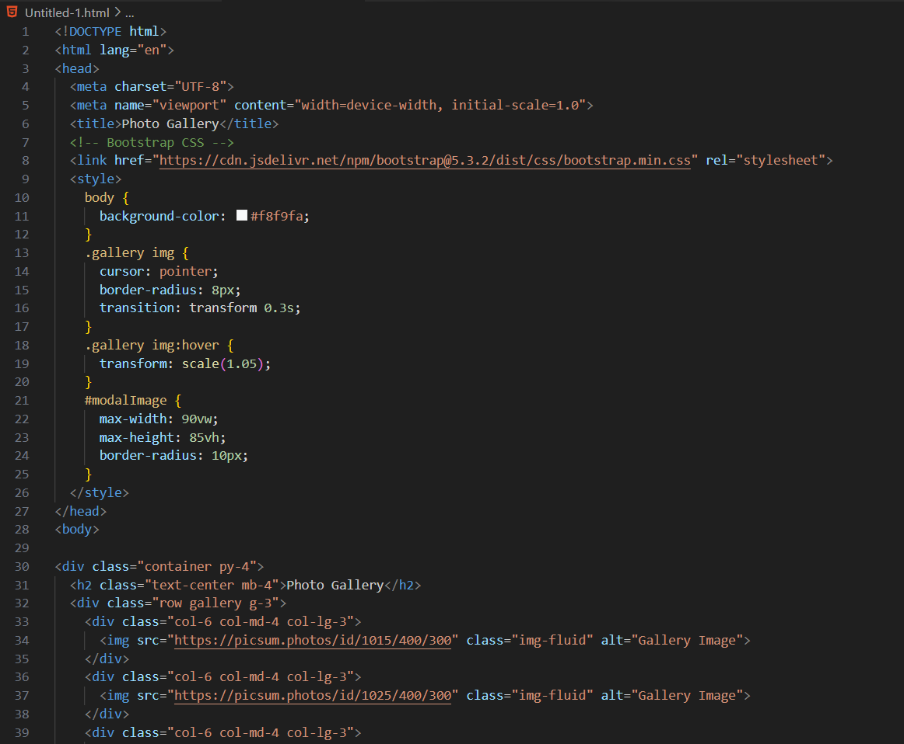

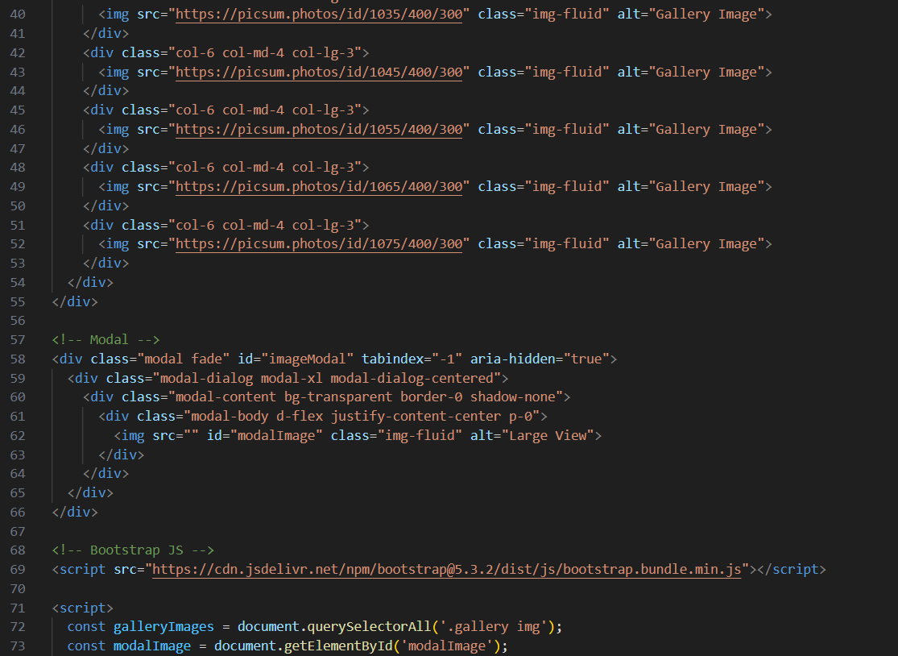

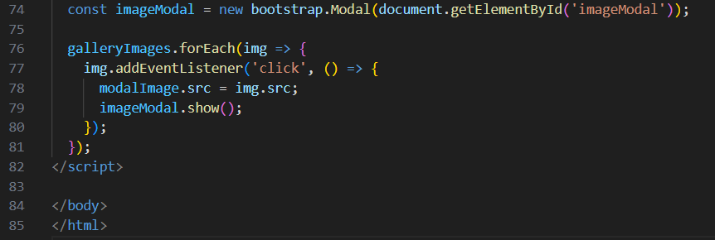

***OUTPUT:***

***BEFORE SELECTING A PHOTO:***

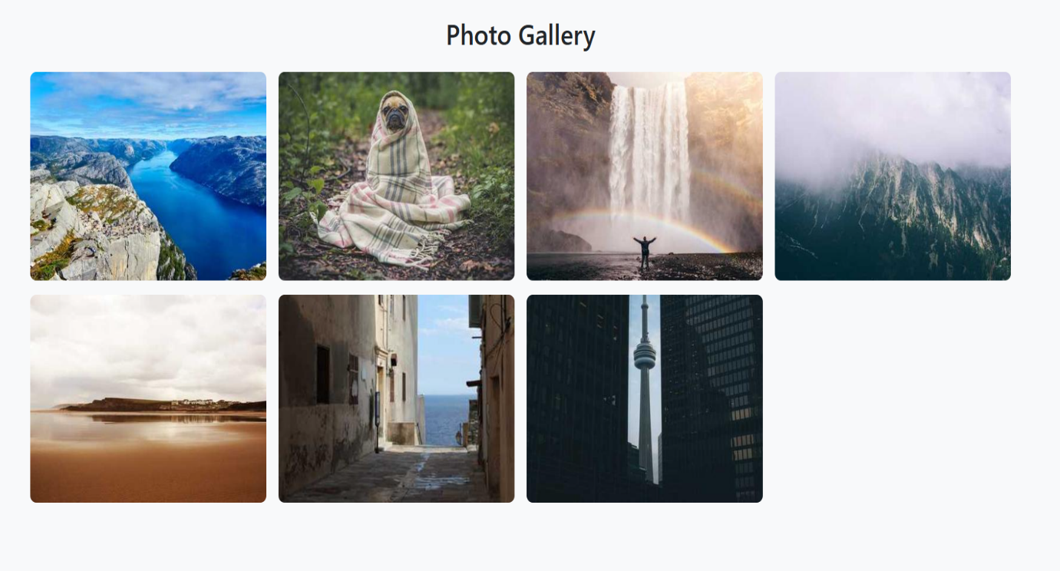

***AFTER SELECTING A PHOTO IN PHOTO GALLERY:***

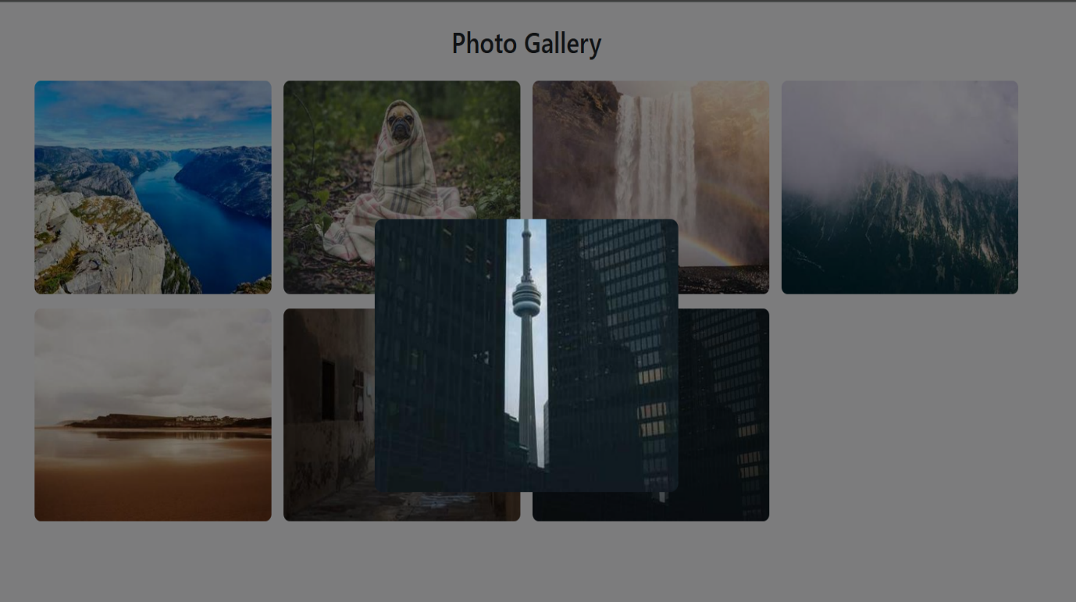

🔚 ***Conclusion:***  
This Photo Gallery and Form Validation project demonstrates how HTML, CSS, Bootstrap, and JavaScript can be combined to build responsive, user-friendly web applications. The photo gallery provides an interactive viewing experience with modals, while the form validation ensures data accuracy and improves usability. The project enhanced our understanding of UI/UX design principles, responsive frameworks, and client-side scripting, strengthening our practical web development skills.

📚 ***References:***  
• MDN Web Docs: https://developer.mozilla.org/  
• Bootstrap Documentation: https://getbootstrap.com/docs/5.3/  
• W3Schools: https://www.w3schools.com/  
• JavaScript.info: https://javascript.info/  
• FreeCodeCamp: https://www.freecodecamp.org/